Lists of values

* Simplest form of arbitrary data

empty



cons Primitive

* (cons <value/exp to be added> <list to be added to>)





cons with expressions



-> 

List of 3 elements



List of images

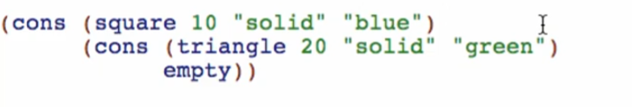

* 

Adding names to list:

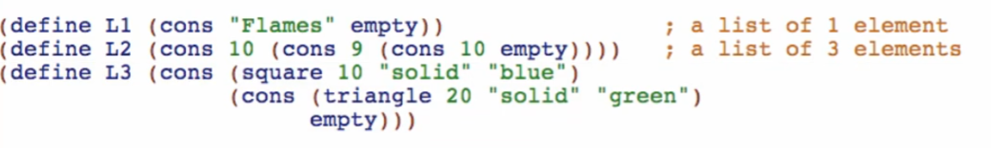

3 more primitives that we can use with lists

* first
  + (first <list>) -> value

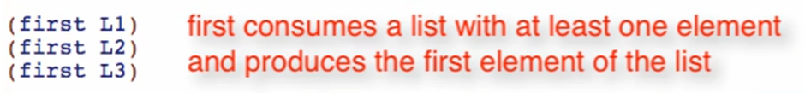

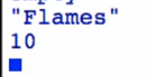

* rest
  + (rest <list>) -> List

Everything after the first element of the list

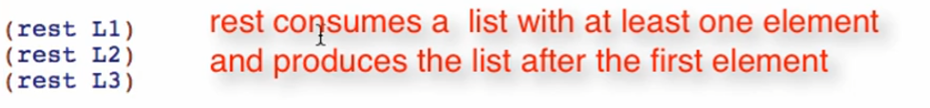

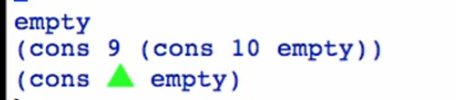

Getting 2nd element: (first (rest L2))



Getting 3rd element: (first (rest (rest L2)))



This will be simplified on the following days

* empty? -> Boolean

 -> 

 -> 

Overview:

